Course Introduction to React
1. Course Intro
Purpose: This section provides a brief overview of React, a popular JavaScript library for building user interfaces.
Example: By the end of this course, learners will build a simple e-commerce app or a task list app, showcasing how React can create dynamic and interactive web applications.
2. Prerequisites
Purpose: You must have a foundational understanding of HTML, CSS, and JavaScript.
Example: A quick refresher on JavaScript, particularly ES6 features like const, let, and arrow functions.
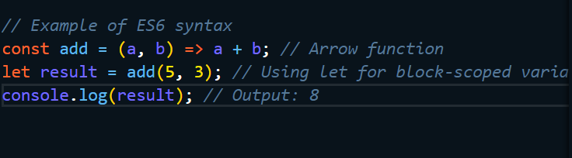

3. What is React?
Purpose: React as a JavaScript library designed for building user interfaces.
Example: how React simplifies DOM manipulation.
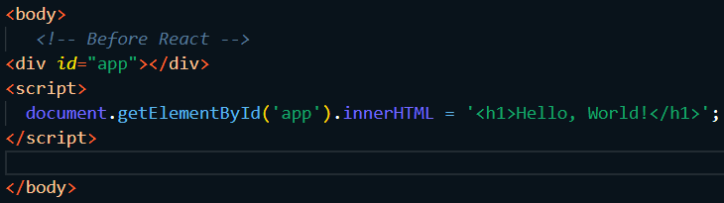
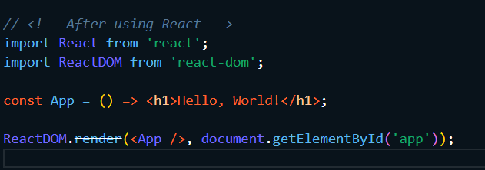
4. Setting up IDE
Purpose: setting up Visual Studio Code (VS Code) and installing essential extensions.
Example: how to install VS Code and extensions like Prettier and ESLint for code formatting and quality.
# Command to install Prettier and ESLint extensions in VS Code
5. Creating a React App
Purpose: how to create the first React project using create-react-app.
Example: Run the command npx create-react-app my-app to set up the project and explaining the generated file structure.
bash
npx create-react-app my-app
cd my-app
npm start # Starts the development server
6. Project Structure
Purpose: the folder and file structure created by create-react-app.Example: Describe the roles of public vs src, focusing on App.js and index.js.
- public/: Contains static files like index.html.
- src/: Contains JavaScript files where components are defined.
- App.js: Main component of the application.
- index.js: Entry point for rendering the app.
7. Components
Purpose: the basics of components, which are the building blocks of React applications.
Example: A simple functional component called WelcomeMessage and render it in App.js.
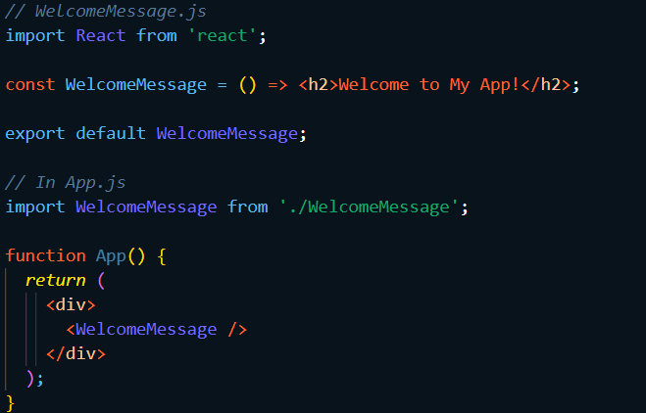
8. How React Works
Purpose: concepts like the virtual DOM, one-way data flow, and component re-rendering.
Example: how state changes trigger efficient re-renders of components.
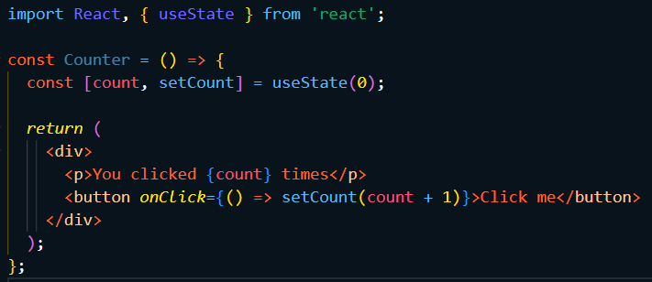
9. Ecosystem
Purpose: an overview of tools related to React such as React Router and Redux.
Example: we’ll likely use libraries like React Router for navigation and Redux for state management in larger applications.
10. Build Components (TOC)
Purpose: creating main components for the project.
Example: components Header, Footer, and ProductList as foundational elements for the application.
11. List Components
Purpose: how to structure components in a list format (e.g., displaying products).
Example: Create a ProductList component that renders multiple Product components.
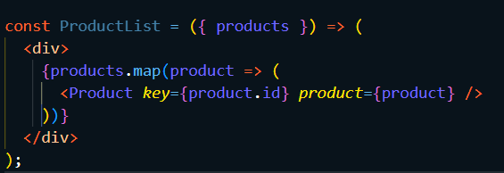
12. Fragments
Purpose: using React Fragments to avoid unnecessary nodes in the DOM.
Example: by wrapping multiple children in <></> compared to using <div>.
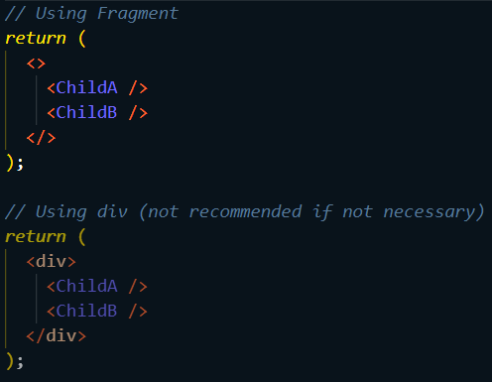
13. Rendering Lists
Purpose: .map() function for dynamically rendering lists.
Example: Rendering an array of items within a component using .map().
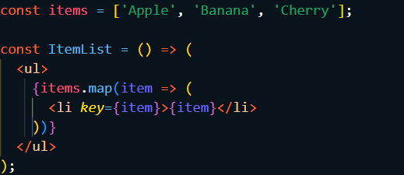
14. Conditional Rendering
Purpose: how to display elements conditionally based on state or props.
Example: Use ternary operators or logical AND (&&) to show/hide elements.
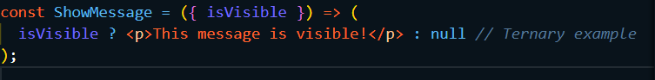
15. Handling Events
Purpose: how to add event listeners in React components.
Example: Adding a button with an onClick event handler that logs a message to the console.
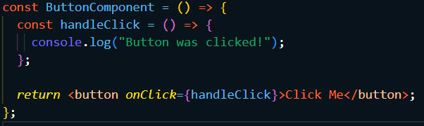
16. Managing State
Purpose: Using useState for managing local state within components.
Example: A counter component that increments or decrements its value with buttons.
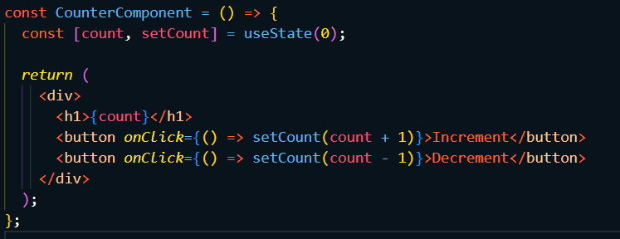
17. Passing Data via Props
Purpose: how to pass data from parent components to child components using props.
Example: Passing a title prop from App.js to a Header component.
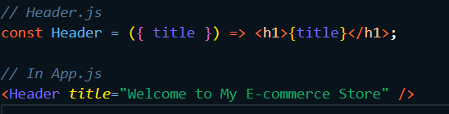
18. Passing Functions via Props
Purpose: how to pass functions as props to handle events in child components.
Example: Creating a button in a child component that triggers a function passed as a prop from its parent.

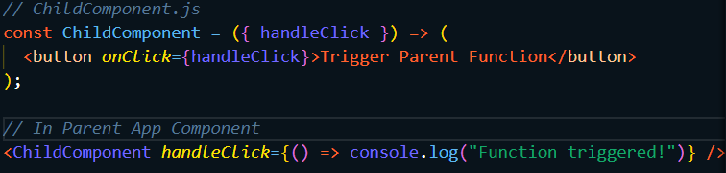
19. State vs Props
Purpose: Now between state (local data managed within component) and props (data passed from parent).
Example:
- Use state in App.js.
- Pass it as props to child components.
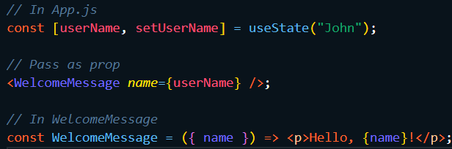
20. Passing Children
Purpose: Explain the concept of children prop for component composition.Example: Create a reusable Card component with content passed as children.

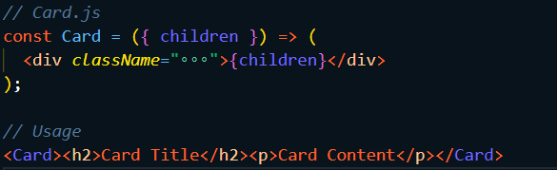
21. React DevTools
Purpose: How to use React DevTools for debugging and inspecting component states and props in the browser.
22. Building a Button Component
Purpose: creating a reusable button component with styles and props for functionality.
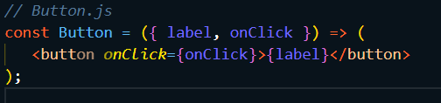
23. Showing an Alert
Purpose: Creating an alert message based on user interaction with buttons or other UI elements.
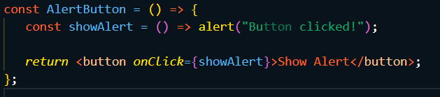
24. Component Lifecycle (Class Components)
Purpose: lifecycle methods such as componentDidMount and componentDidUpdate.
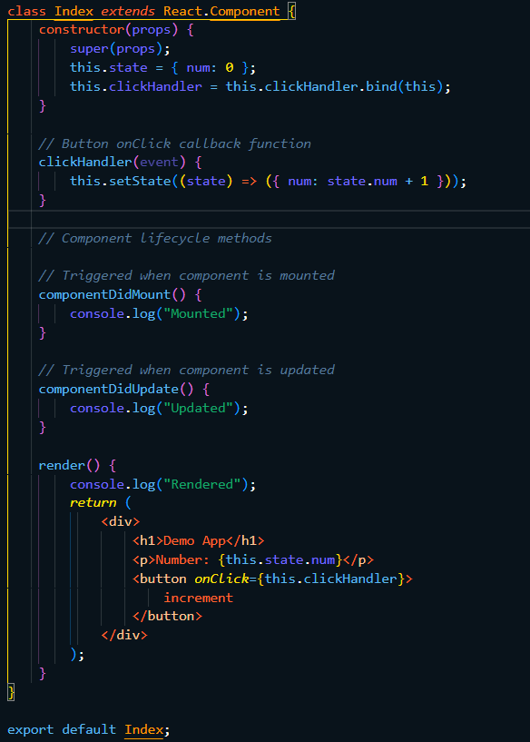
25. useEffect Hook
Purpose: how to use the useEffect hook for handling side effects in functional components such as data fetching or subscriptions.
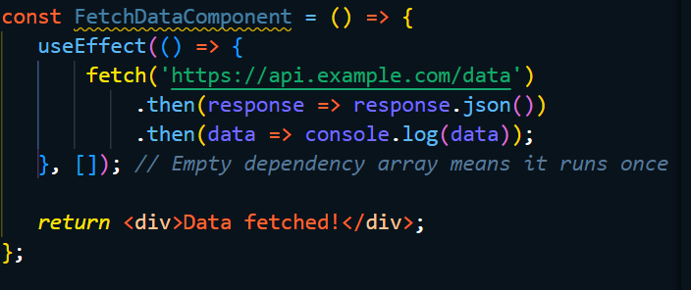
26. Using Context for State Management
Purpose: Context API for managing global state across components without prop drilling.
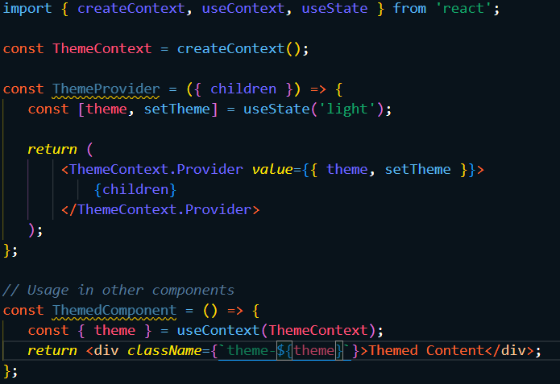
27. useReducer Hook
Purpose: how to manage complex state logic using the useReducer hook instead of multiple calls to useState.
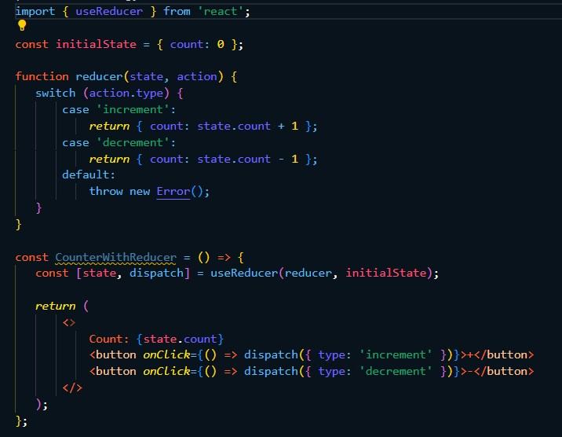
28. Custom Hooks
Purpose: creating reusable logic with custom hooks for tasks like data fetching or form handling.
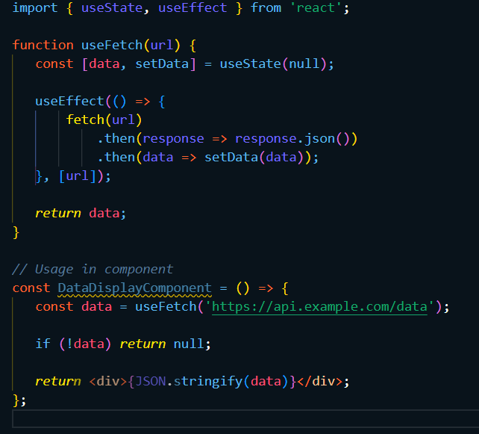
29. React Router Basics
Purpose: how to implement routing in single-page applications using React Router for navigation between different pages/components without full page reloads.
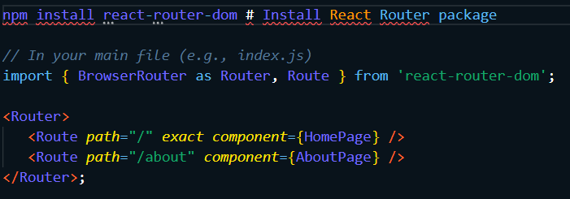
30. Nested Routing
Purpose: how nested routes can be used for more complex app structures involving sub-pages or sections within pages.
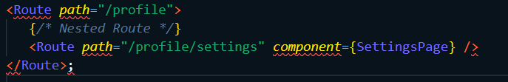
This structured approach provides students with both theoretical knowledge and practical coding exercises essential for mastering React development effectively.

